Sequence Diagram - Case Studies

Case 1
In a withdrawal transaction of an ATM Machine system the customer inserts his ATM card in the machine. The machine then verifies the customer authentication using the information provided in customer account. After successful verification the machine takes withdrawal request from the customer and checks whether the request is valid or not. A valid request is carried out by the machine and an invalid request is rejected. In case of unsuccessful verification the customer request is denied.
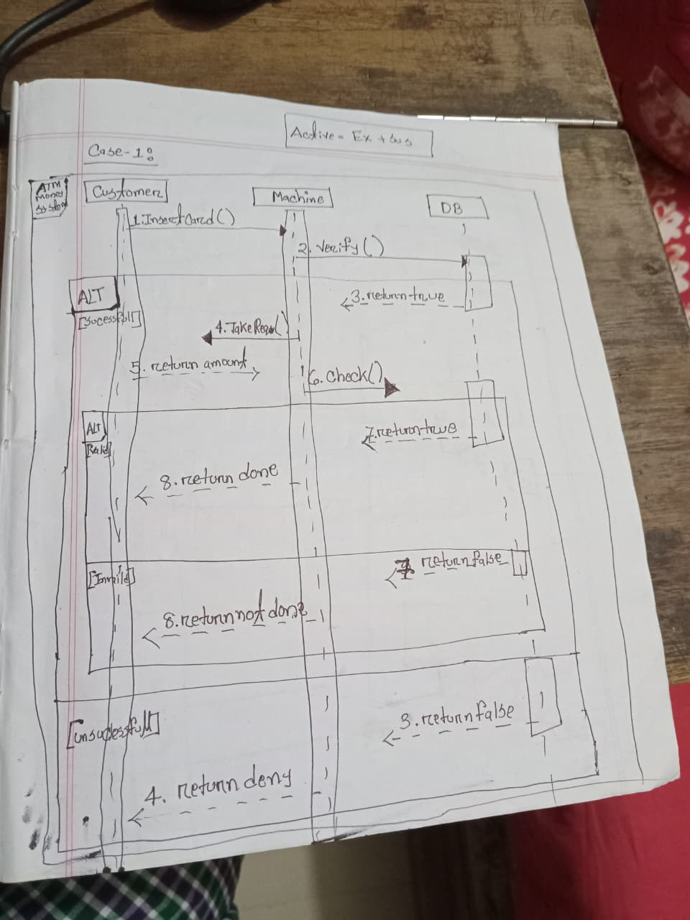

Case 2
In a library management system of a student can borrow books. When a student brings the books he wants to borrow to the librarian, the librarian places a borrowing request by scanning the student ID. A borrowing object is created at that time which performs all the borrowing related tasks. It checks the student status from the database. If the student is a regular student and doesn’t have any overdue book, the system allows for the books to be scanned. After the books are scanned the data is written in the database and the librarian is informed at the same time. If the student is regular but already has overdue books with him, the request is denied. If the student status is not regular, the request is also denied.
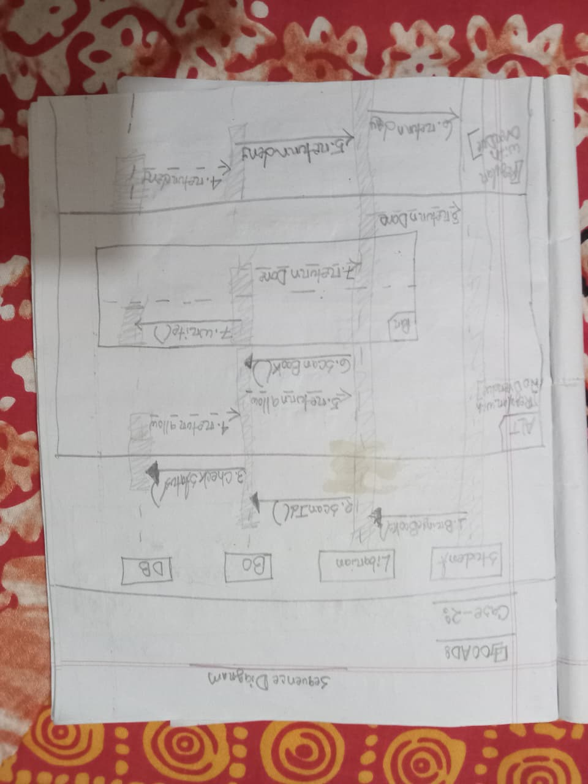
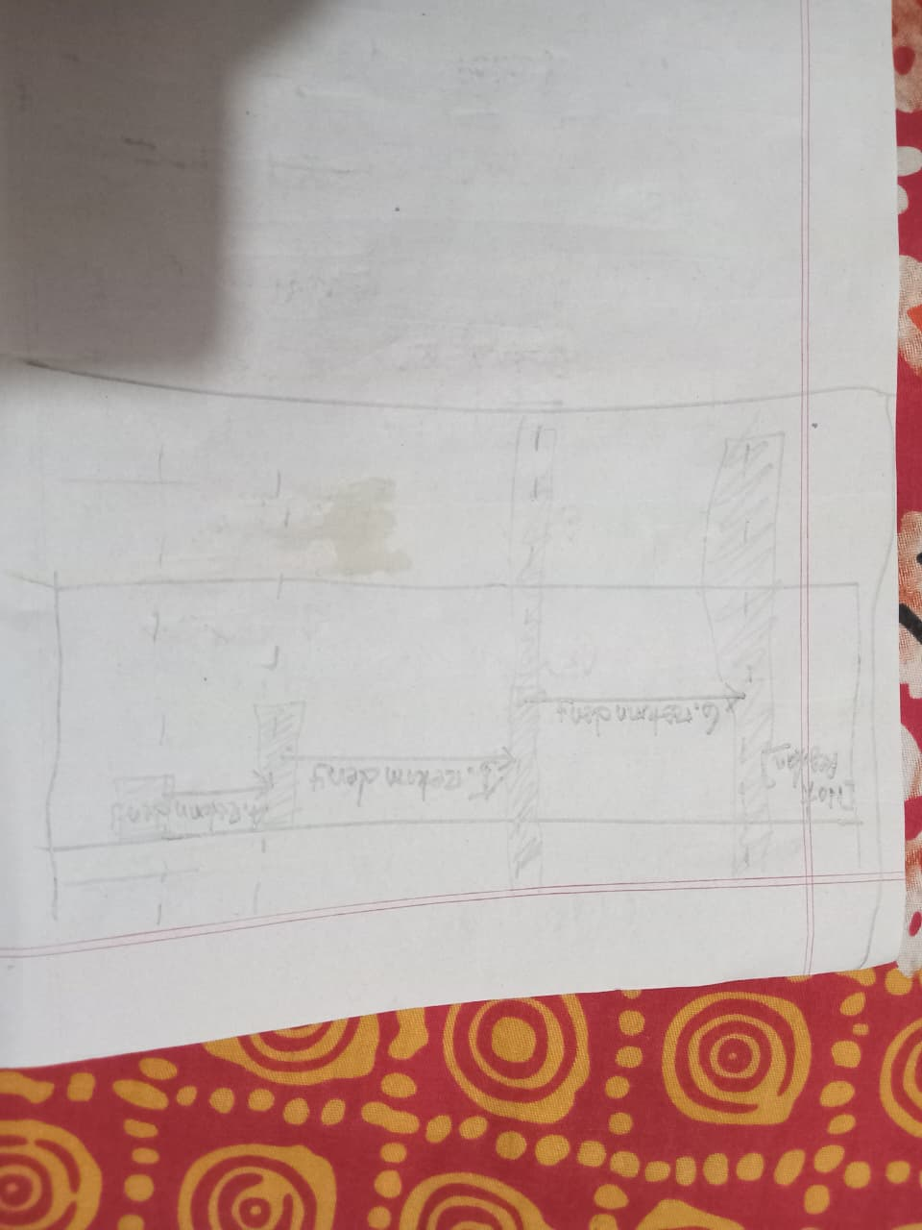

Case 3
A doctor includes instructions in the patient’s advice when a patient requires a bed or room in the hospital. The advice is then passed to the office clerk. The office clerk checks the present booking database to get the available room and bed list. Facilities of the rooms and the beds are then extracted from the room list. Available room and bed numbers and facilities are sent to the patient. The patient chooses a room or bed and then the office clerk writes patientid, room or bed no, doctorid and doctor’s advice in the booking database. Finally, a copy of the admission is sent to the associated nurse, and a copy is given to the patient simultaneously.
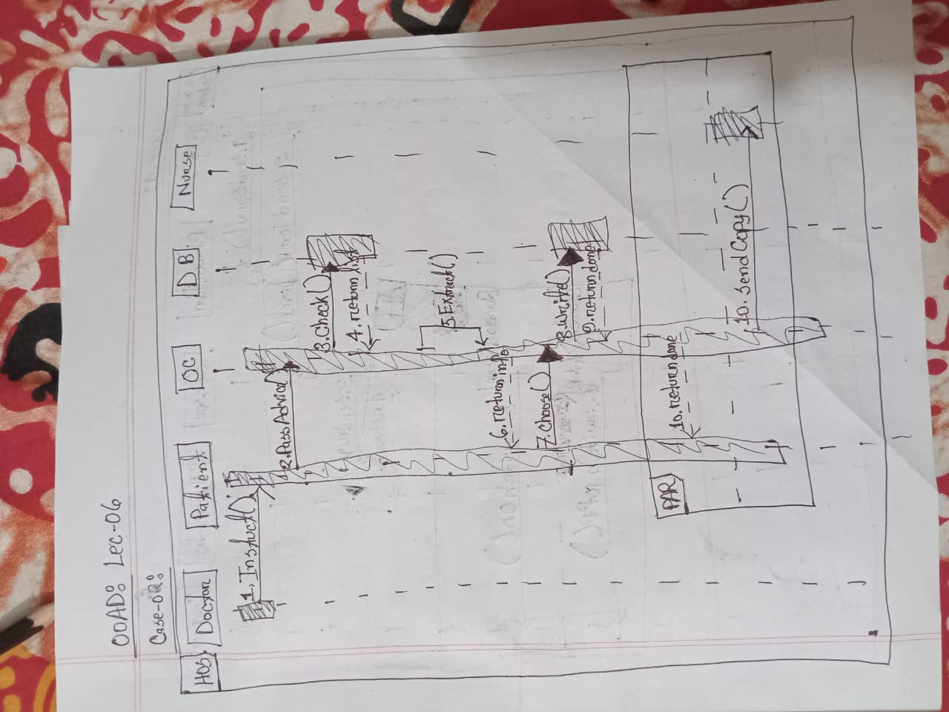

Case 4
When an air cooler starts, the control switch sends signal to the blower fan to start at the level that is already set in the control switch. Then the control switch sends the level of temperature to the sensor. The sensor senses the outside temperature by sending a request to the thermostat and if the outside temperature is higher then the level sent by the control switch, the sensor send signal to the compressor to switch on. When the sensor outside temperature goes down to the set level, the thermostat sends signal to the sensor and the sensor in turn sends signal to the compressor to switch off. The process keeps on running in a cycle as long as the air cooler stays on.
